*

Name : Yogesh Dinesh Joshi
Sap id : 590025632
Batch : 34
Teacher : Sugandha Sharma

Python Programming : Experiment 2

Q1 : Check whether the given number is divisible by 3 and 5 both.
Code : 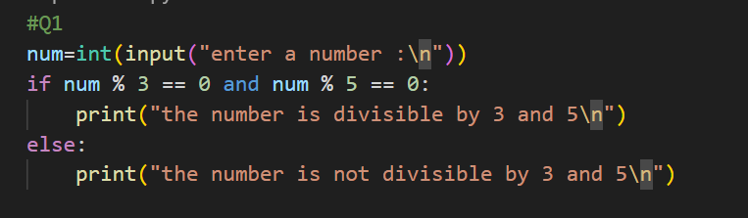
Output :
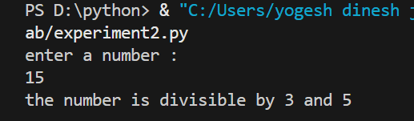
Q2 : Check whether a given number is multiple of five or not.
Code : 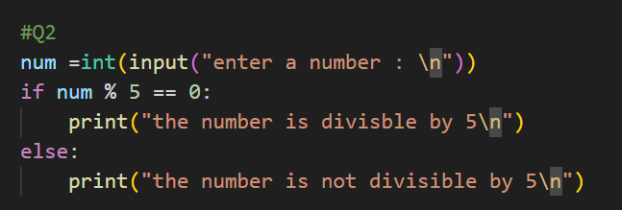
Output : 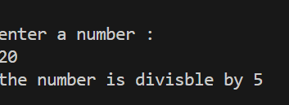

Q3 : Find the greatest among the two numbers. If numbers are equal than print “numbers are equal”.
Ans : Code : 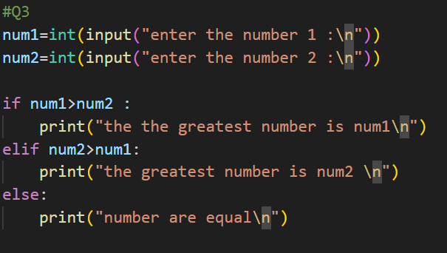
Output : 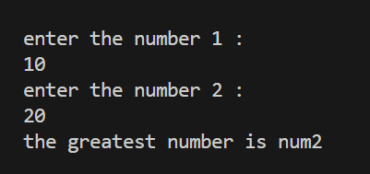

Q4 : Find the greatest among three numbers assuming no two values are same.
Ans : Code : 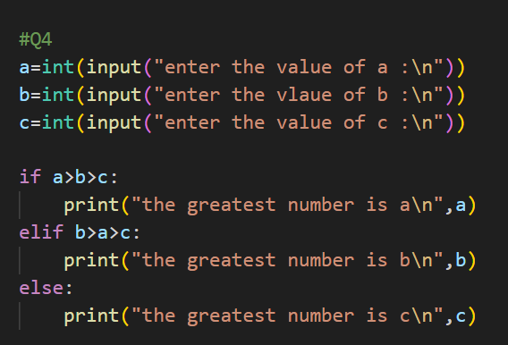

Output : 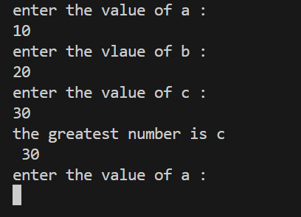

Q5 : Check whether the quadratic equation has real roots or imaginary roots. Display the roots.
Ans : Code : 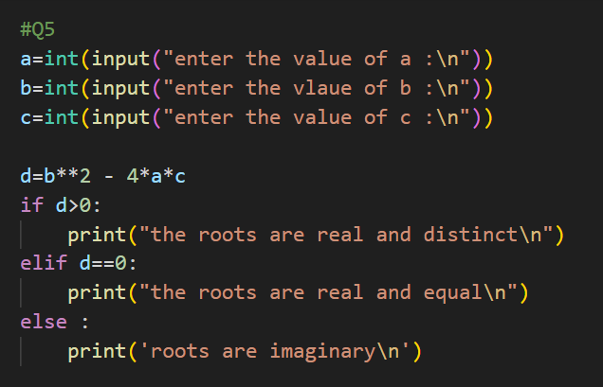
Output ; 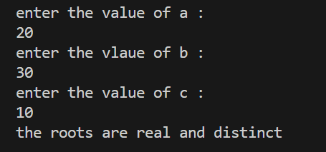
Q6 : Find whether a given year is a leap year or not.
Ans : Code : 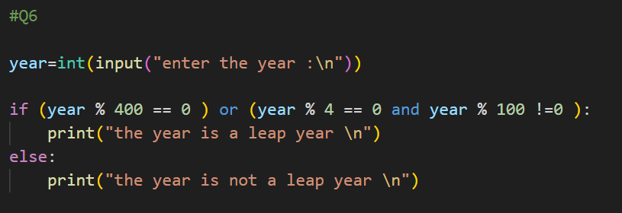
Output ; 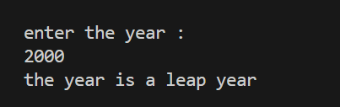

Q7 : Write a program which takes any date as input and display next date of the calendar.
e.g.
I/P: day=20 month=9 year=2005
O/P: day=21 month=9 year 2005

Ans : Code : 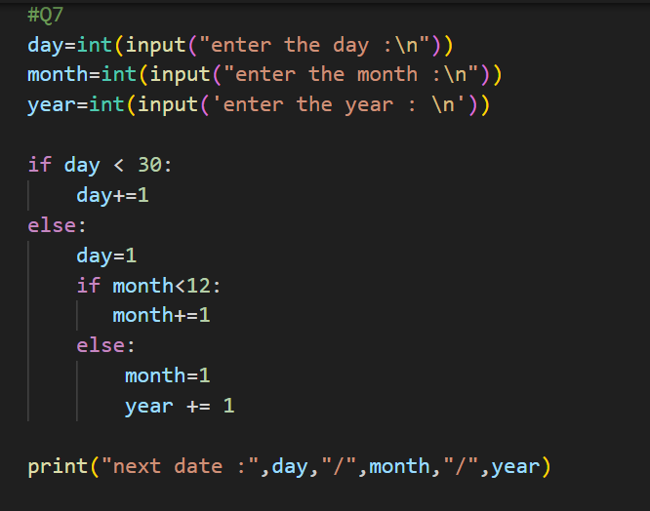
Output : 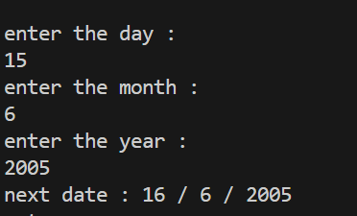

Q8 : Print the grade sheet of a student for the given range of cgpa. Scan marks of five subjects and calculate the percentage.
CGPA=percentage/10
CGPA range:
0 to 3.4 -> F
3.5 to 5.0->C+
5.1 to 6->B
6.1 to 7-> B+
7.1 to 8-> A

Ans : 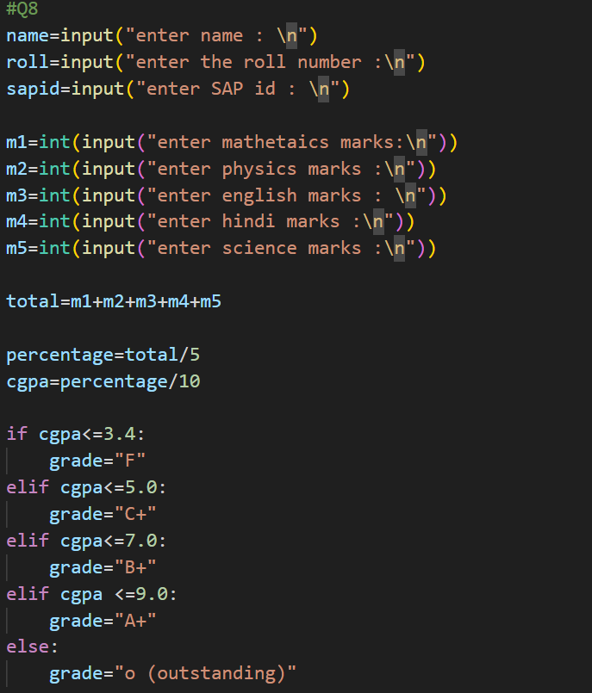
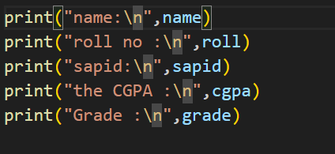
Output : 